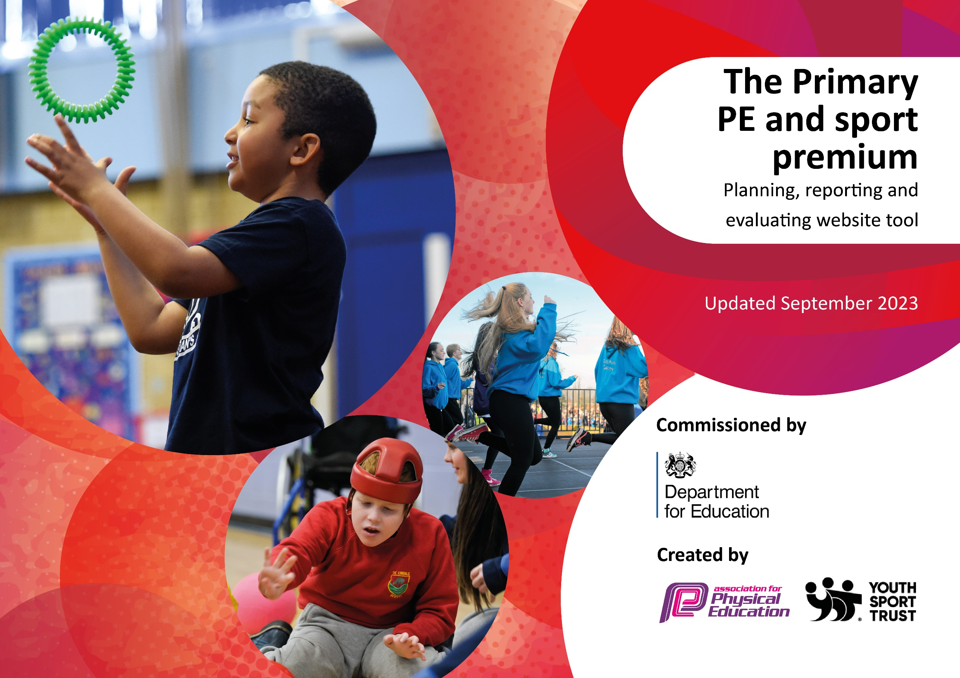

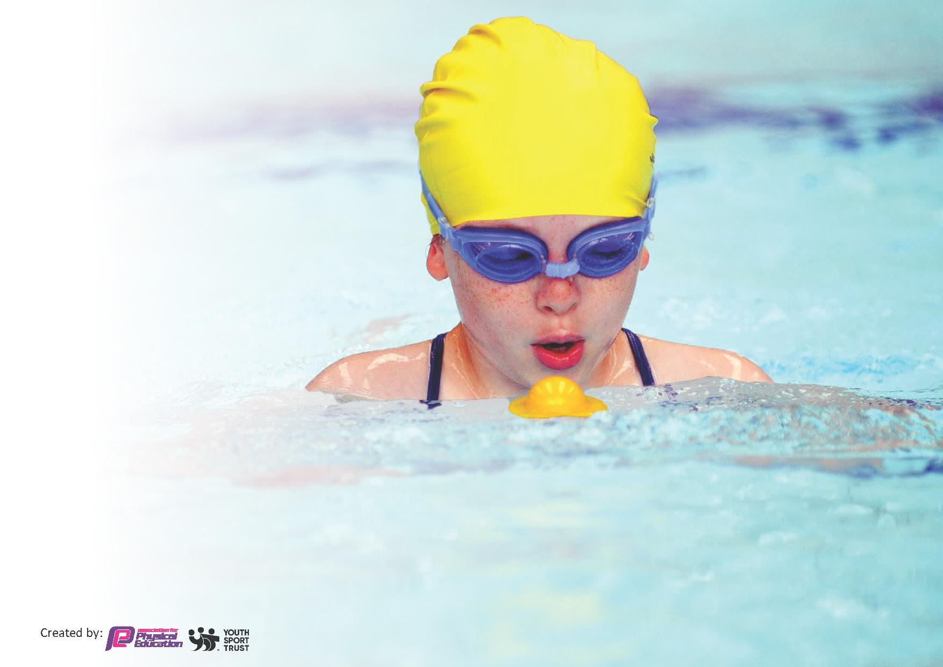
This template can be used for multiple purposes:
by:
- It enables schools to effectively plan their use of the Primary PE and sport premium
- It helps schools to meet the requirements (as set out in guidance) to publish information on their Primary PE and sport premium
- It will be an effective document to support Ofsted inspections enabling schools to evidence progress in Physical Education (PE) and evidence swimming attainment, which forms part of the PE National Curriculum. We would recommend schools consider
the Intent, Implementation and Impact of any spend, as examined within the Education Inspection Framework.

It is important that your grant is used effectively and based on school need.

Schools must use the funding to make additional and sustainable
improvements to the quality of the PE, School Sport and Physical Activity (PESSPA)
they offer. This means that you should use the Primary PE and sport premium to:

- Build capacity and capability within the school to ensure that improvements made now will benefit pupils joining the school in future years
- Develop or add to the PESSPA activities that your school already offers.

The Primary PE and sport premium should not be used to fund capital spend projects; the school’s core budget should fund these. Further detail on capital expenditure can be found in the updated Primary PE and sport premium guidance.

The Primary PE and sport premium guidance, outlines 5 key priorities that funding should be used towards. It is not

necessary that spending has to meet all the key priorities, you should select the priorities that you aim to use any funding towards.

Although completing this template is not a requirement for schools, schools are required to publish details of how they spend this funding. Schools must also outline what the impact this funding has had on pupils’ PE and sport participation and attainment and how any spending will be sustainable in the future. All funding must be spent by 31st July 2024.

The Department for Education has worked closely with the Association for Physical Education (afPE) and the Youth Sport Trust (YST) to develop this template and encourages schools to use it. This template is an effective way of meeting the reporting requirements of the Primary PE and sport premium.
Review of last year’s spend and key achievements (2022/2023)

We recommend you start by reflecting on the impact of current provision and reviewing your previous spend.

Activity/Action | Impact | Comments
- Events that pupils have taken part in locally within the cluster have been consistent across the year and pupils have committed to taking part. Cross country, football & netball leagues have been ongoing from Autumn Term.  - Pupils have been encouraged to take part regardless of ability; those who have attended sessions have also competed.  - Staff have worked with SCNW to improve pupil participation of sport, to offer a wider range of sports, to improve own CPD. | - Pupils have been able to experience a variety of competitive sports. They have built upon their teamwork skills and also developed their sporting attitudes.  - Staff are more confident in teaching PE. Sport has been promoted at various times throughout the school day. SCNW actively engage pupils in sports during lunchtimes and as part of our wrap around care. Pupils are developing their confidence and enjoying experiencing a range of sports. | - Continue to engage in local cluster competitions.  - Continue to engage those inactive pupils in smaller group activities.  - Trust events to support inactive pupils is planned for next year.  - Engage with professionals offering workshops around physical health linked to mental well-being.  - Sharing experiences of individuals who have struggled with own body image and also mental health issues-how sport and physical activity has helped them.

Key priorities and Planning
This planning template will allow schools to accurately plan their spending.

Action – what are you planning to do | Who does this action impact? | Key indicator to meet | Impacts and how sustainability will be achieved? | Cost linked to the action
Provide opportunities for the pupils to access physical activities during lunchtimes and break times.  Varied sports on offer to inspire and entice new interest.  Encourage and target inactive pupils to participate in activities. | PE Leader  Pupils  Teaching staff  SCNW Coaches | Key indicator 1: The engagement of all pupils in regular physical activity – Chief Medical Officer guidelines recommend that primary school pupils undertake at least 30 minutes of physical activity a day in school | Increase in engagement across all year groups with more sports coaches available over the different key stages at lunch time. More equipment and a variety of sports offered.  Regular meetings and feedback with SCNW to improve provision.  Pupil voice – pupils share their favourite activities or what they would like to try.  Consistent coaches each day – get to know pupils better and vice-versa.  Next steps to look at how school day is structured and whether we can include additional physical activity.  Provide additional training for Lunchtime staff. | SCNW Contract: £14,040  Supply cover to enable training for lunchtime staff: £600

*Utilising expert coaches from Sports Coaching North West to offer additional activities such as multi sports/ tennis/ football/ cricket/ archery/ dance/ basket balls to engage a different group of pupils.  *More pupils to engage in competitions through higher expectations of pupils’ outcomes in PE as well as increased expectations across the curriculum.  *School Sports partnership membership for local competitions.  *Time for curriculum leader to review with staff curriculum maps and specifically identify more active learning and links to healthy lifestyles. Golden thread across the curriculum.  *Annual subscription to the Association of PE to provide additional materials to support PE Leads and teachers. | PE Leader  Pupils  Teaching staff  SCNW Coaches | Key indicator 2: The profile of PESSPA being raised across the school as a tool for whole school improvement | Increased participation in after school sports and lunch time provision  PE is a high focus area for our school and the opportunity to take part is available for everyone. Able to take more than one team to represent the school. Changed teams each week to ensure all pupils who wanted to participate could.  Increased confidence in staff subject knowledge. Increased coverage through other areas of the curriculum.  To continue involvement with competitions and invite more year groups to participate.  To target inactive pupils.  To provide opportunities for real competition for LKS2 and KS1 as well as continuing to participate in the UKS2 competitions.  To continue to make the link of being active with good mental health and the benefits of leading a healthy, active lifestyle. | SCNW Contract: £14,040  School Games cluster competitions – £250  Subscription to Association for PE - £115  Supply cover for PE leaders to monitor PE: £600
RR & BM to observe quality first teaching in PE and feedback and review PE plan for next year.  Share best practice and ideas with other PE leaders in St Bart’s MAT.  Plan ahead for competitions and joint activities.  PE Passport to be followed across the school to support staff with lesson planning, assessment and monitoring  Staff to become active and share with pupils to encourage a happy and healthy lifestyle.  PE prefects to set up activities with reception and preschool children.  Sale Sharks to deliver high quality rugby sessions to Year 6 on a weekly basis.  Cheshire Cricket Board to deliver high quality cricket sessions to various year groups. | PE Leader  Pupils  Teaching staff  SCNW Coaches  Other PE Leaders in the Trust | Key indicator 3: Increased confidence, knowledge and skills of all staff in teaching PE and sport | Increased subject knowledge & confidence  Results from baseline to end of program improvement. Teaching staff to observe & develop knowledge.  Staff feeling more confident to teach high quality PE.  Clear monitoring of PE across all year groups.  Improved provision through continuing to link with other Trust schools to share best practice and next steps through the Network Meetings.  Review action plan ready for September and update the long term plan to give better coverage and opportunities for a variety of sports.  Monitoring quality of PE for staff | Annual Subscription to PE Passport: £300  Supply cover for PE leaders to monitor PE and engage in CPD within SBMAT: £1000
*High quality resources available for the pupils to engage in physical activity.  *Developing the environment further to offer more opportunities.  *New playground equipment.  *New curriculum equipment purchased to allow a higher standard of PE to be taught and a wider variety of sports to be taught.  *Safety of equipment checked outdoor and indoor.  *Linking physical activities to Maths and literacy.  *Set up course around school with different signs which encourage pupils to ‘think’ for a minute and talk about deeper things.  *All pupils competing in varying sporting activities.  *Sale Sharks to deliver high quality rugby sessions to Year 6 on a weekly basis.  *Cheshire Cricket Board to deliver high quality cricket sessions to various year groups. | PE Leader  Pupils  Teaching staff  SCNW Coaches  Other PE Leaders in the Trust | Key indicator 4: Broader experience of a range of sports and activities offered to all pupils | More pupils engaging with activities at lunchtimes and then giving other extra-curricular activities a go.  More evidence of outdoor learning activities across a range of subjects.  National initiative, competition between classes. Certificates awarded to pupils. Displays in school.  To maintain engagement and look at school day timings to add in further physical activity where possible.  Curriculum development to identify opportunities across all subject areas linked to physical activity.  Continue to book a swimming pool for school to use to allow all KS2 pupils to have the opportunity to access swimming. | New playground equipment (Contribution towards) : £3,195
To participate in local league competitions throughout the year.  Successful Sports Day to go ahead for all pupils with competitive races of varying activities. | PE Leader  Pupils  Teaching staff | Key indicator 5: Increased participation in competitive sport | Many pupils taking part in league games and tournaments who have not taken part before. Pupils coming forward to ask if they can take part.  All pupils active and involved. All pupils celebrated for taking part and having a go.  Continue to encourage all pupils to take part in clubs and events that we do put in mixed ability teams so that pupils can all compete.  Work alongside Trust schools to organize events and host.  Cover costs of venue hire with other Trust schools in a central location. Transport arranged between schools.

Key achievements 2023-2024
This template will be completed at the end of the academic year and will showcase the key achievements schools have made with their Primary PE and sport premium spending.

Activity/Action | Impact | Comments
Introduce lunchtime sport sessions/activities for pupils.  Purchase new sports equipment in line with our PE curriculum  Playground boxes  Annual subscription to PE Passport  Participation within local cluster, trust and School Games competitions  Cheshire Cricket - CPD  Sports Day  Olympics Day  SEND Olympics  Swimming | More pupils meeting their daily physical activity goal, more pupils encouraged to take part in PE and Sport Activities.  Children have participated in a wide range of activities such as netball, football, cricket, badminton, tennis, archery, gymnastics, dance and athletics.  To provide an effective PE curriculum and allowing children off all abilities to access sessions.  To allow a higher standard of PE to be taught and a wider range of activities to be on offer.  High quality resources available for the children to engage in physical activity. This has encouraged less active pupils to take part and use the equipment during lunchtimes and playtimes.  Clear lesson plans and additional materials to support teacher.  This has provided an opportunity for children of different ages to represent the school in a variety of sports. Children who attended clubs provided by the school were then able to compete.  We have seen increased participation in competitive sport.  We have offered a broader and more equal experience of a range of sports and physical activities to all pupils  Cheshire Cricket provided sessions for KS1 and KS2 children, which were also used as CPD for teachers increasing their confidence, knowledge and skills in teaching PE and sport.  All pupils (Pre-school – Y6) were active and involved. All pupils were celebrated for taking part and having a go.  We increased the engagement of pupils, raised the profile of PE and sport across the school and offered a broader and more equal experience of a range of sports and physical activities to all pupils.  Many children took part who have not represented or taken part in school activities before.  Children were able to access all of the activities and engage in a broad range of activities.  Children in KS2 took part in swimming lessons within school courtesy of a ‘pop up’ pool. Less able swimmers were able to have additional lessons to enable further practice. | To continue with lunchtime sport across the KS1 and KS2, to provide children with extra sporting opportunities.  We have aimed to use the same coaches each day to ensure that the children are familiar with the coaches and vice versa.  Next steps: Ask the children which activities they would like to participate in.  Pupil Voice  To continue to monitor and complete audits on equipment to ensure the appropriate equipment is available.  We linked with trust schools for quality assurance and shared good practice  Renew our annual subscription.  Increased coverage in staff subject knowledge.  Next steps: Provide CPD for staff – Staff meeting within the Autumn term.  Children within KS2 have been able to regularly participate in competitions. Some competitions were league formats which were held over multiple weeks whereas others were one-off competitions. This year, we reached the county finals in basketball and cricket.  Next year, we will continue to participate and encourage all children of all abilities to compete.  Next steps: organise more events with PE leads across the trust.  Cheshire cricket have agreed to provide sessions and CPD for a term in Spring 2025. We will also be providing a cricket after school club which will be ran by Cheshire Cricket.  During our Olympics day, the children from Reception to Year 6 participated in 4- sessions throughout the day. The children participated in a variety of activities which were led by specialists. The activities included rugby, football, netball, gymnastics, martial arts, an obstacle course, archery, curling, athletics and goal ball.  This event was held within the trust.  Next steps: To continue to link with other Trust schools to organise and attend events.  Every child within KS2 was given the opportunity to practise their swimming.  Next steps: Due to cost implications and demographics, during the next academic year the school will use a local facility in Summer term.

Swimming Data
Meeting National Curriculum requirements for swimming and water safety.
Priority should always be given to ensuring that pupils can perform safe self-rescue even if they do not fully meet the first two requirements of the National Curriculum programme of study

Question | Stats: | Further context  Relative to local challenges
What percentage of your current Year 6 cohort can swim competently, confidently and proficiently over a distance of at least 25 metres? | 80% | Use this text box to give further context behind the percentage.  e.g., 30% - we are struggling to get pool space due to our local pool closing so we have had to use a much smaller local school pool. We have had to limit the number of pupils attending swimming lessons during one term which means some pupils have attended fewer swimming lessons than others.
What percentage of your current Year 6 cohort can use a range of strokes effectively [for example, front crawl, backstroke, and breaststroke]? | 80% | Use this text box to give further context behind the percentage.  e.g., Even though your pupils may swim in another year please report on their attainment on leaving primary school at the end of the summer term 2024

What percentage of your current Year 6 cohort are able to perform safe self-rescue in different water-based situations? | 80% | Use this text box to give further context behind the percentage.
If your schools swimming data is below national expectation, you can choose to use the Primary PE and sport premium to provide additional top-up sessions for those pupils that did not meet National Curriculum  requirements after the completion of core lessons. Have you done this? | N/A
Have you provided CPD to improve the knowledge and confidence of staff to be able to teach swimming and water safety? | Yes/No | External provider hired

Signed off by:

Head Teacher: | Mrs H Hewitt
Subject Leader or the individual responsible for the Primary PE and sport premium: | Miss A Jones (Vice Principal) & Mr S Goodwin (PE Lead)
Governor: | Mr A Clifton
Date: | 18.09.23  Reviewed 17.07.24

