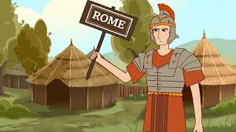

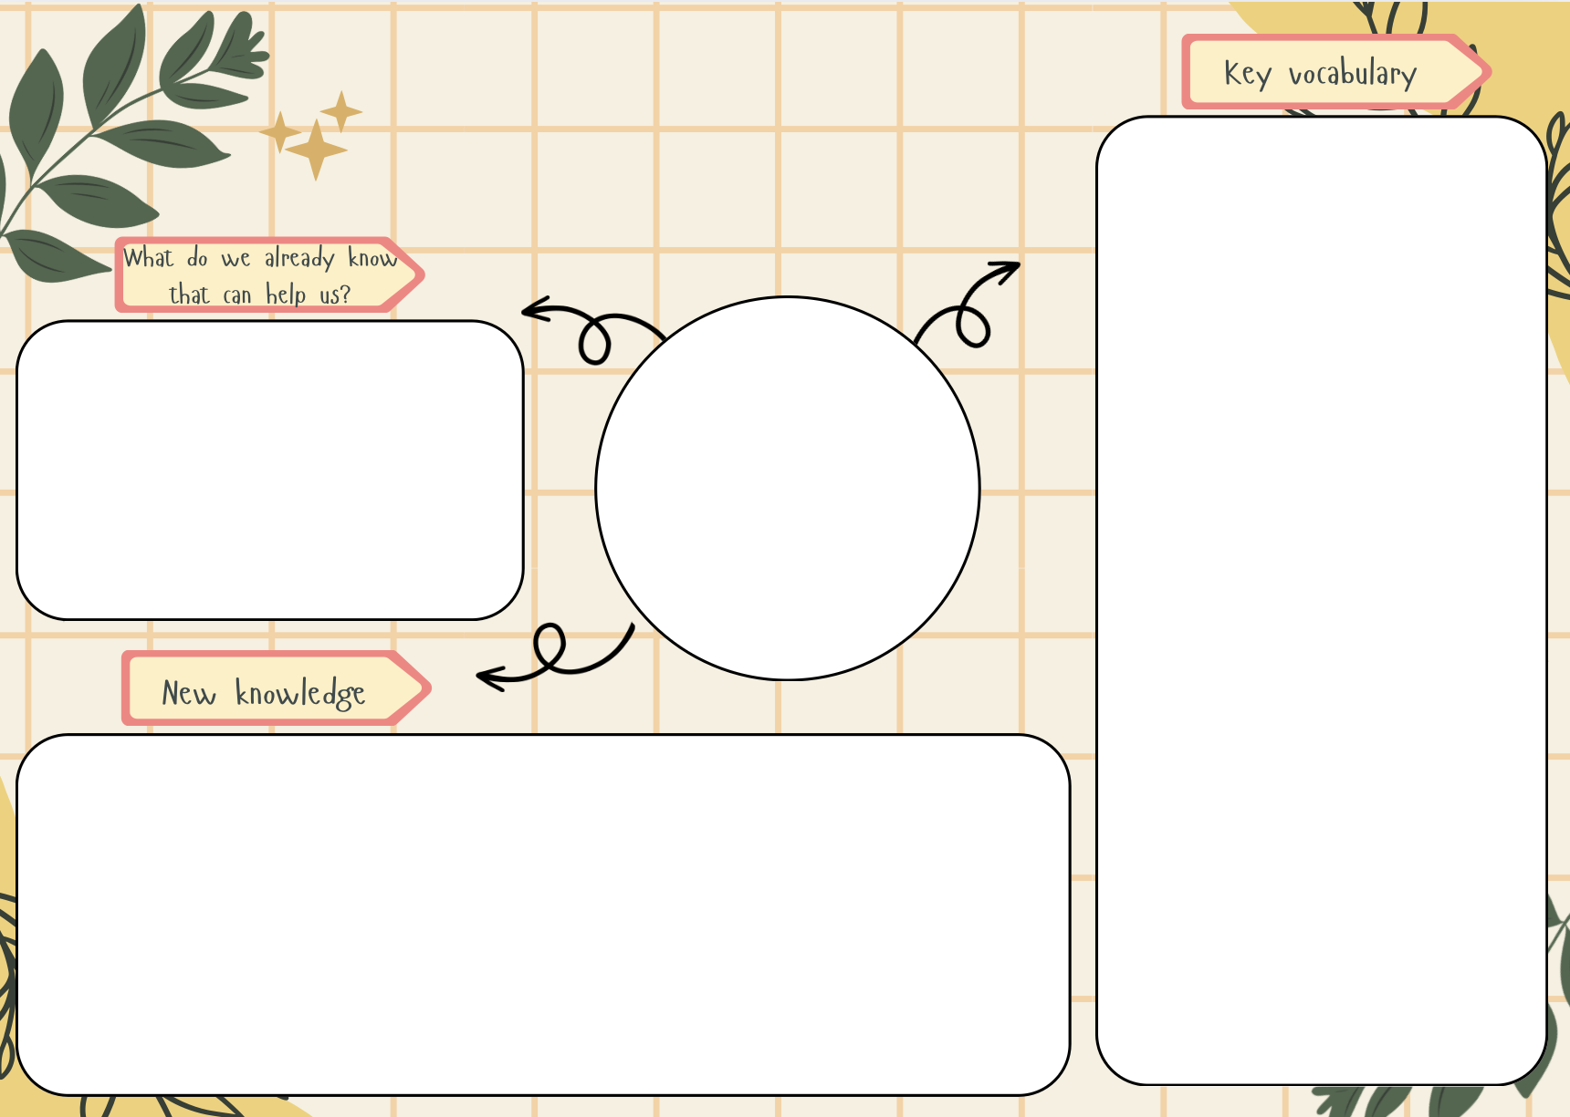
- The Stone Age came more than 3000 years BC.
- The Bronze Age came after the Stone Age.
- Life was very different during the Stone Age and Bronze Age.
Invasion - an instance of invading a country or region with an armed force.
Empire - an extensive group of states or countries ruled over by a single monarch, an oligarchy, or a sovereign state.
Colony - a country or area under the full or partial political control of another country and occupied by settlers from that country.
Conquest – the assumption of control of a place or people by military force.
Christianity - the religion based on the person and teachings of Jesus Christ
AD – Anno Domini
BCE – Before the Common Era
Emperor – a sovereign ruler of an empire.
Chariot - a two-wheeled vehicle drawn by horses, used in ancient racing and warfare.
Gladiator – a man trained to fight with a weapon in an arena.
- The Roman Empire expanded over 503 years.
- It started in 31BC and ended in AD476.
- Julius Caesar was a Roman Emperor.
- There were two failed invasions of Britain in 55 and 54BC.
- Emperor Claudius successfully invaded Britain in AD43.
- Boudicca (queen of the Iceni tribe) led a rebellion against the Romans.
- Cartimandua (queen of the Brigantes) was allied to the Romans.
- The Roman Empire expanded across the whole of Europe.
The Romans
History

