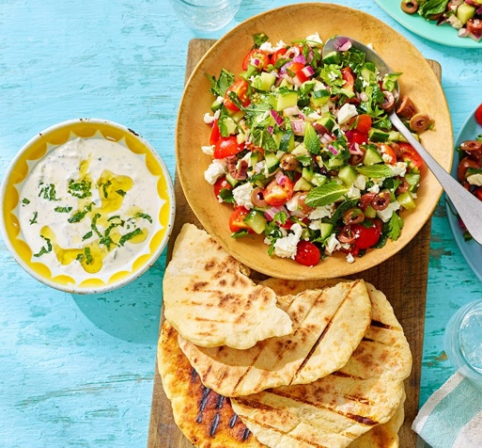

Key Vocabulary:
• ingredient – a food item used to make a dish.
• recipe – a set of instructions explaining how to make a dish.
• method – the ordered steps followed to make something.
• measure – to find the correct amount of an ingredient.
• weigh – to measure an ingredient using scales.
• blend – to mix ingredients until smooth.
• consistency – how thick, thin, smooth or runny a mixture is.
• cross-contamination – when bacteria or allergens are transferred from one food or surface to another.

Recommended Wider Reading:

• Look at child-friendly Greek food and culture books.
• Explore a simple flatbread recipe and identify the ingredients and method.
• Read recipes for hummus and tzatziki and compare the instructions.
• Use food labels to investigate ingredients and allergens.

What do we already know?
Last year, we made pizzas and followed a recipe.
• We have practised measuring ingredients and preparing food.
• We know some basic food hygiene and kitchen safety rules.
• We have used techniques such as chopping, mixing, rolling and grating.
• We can evaluate food by discussing taste, texture and appearance.

Key Knowledge/Skills:

• Follow a recipe carefully and in the correct order.

• Measure and prepare ingredients accurately.

• Use kitchen equipment safely, including knives and graters.

• Understand why good food hygiene and handwashing are important.

• Consider allergens and avoid cross-contamination.

• Make and shape flatbread dough using appropriate techniques.

• Prepare Greek-inspired dips such as hummus and tzatziki.

• Evaluate taste, texture, appearance and smell.

• Adapt a recipe by considering flavour combinations and personal preferences.

Year group: 5
Term: Autumn 1

