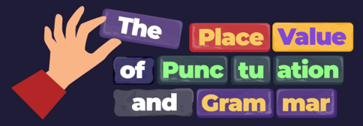
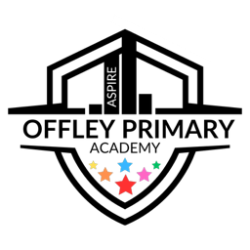
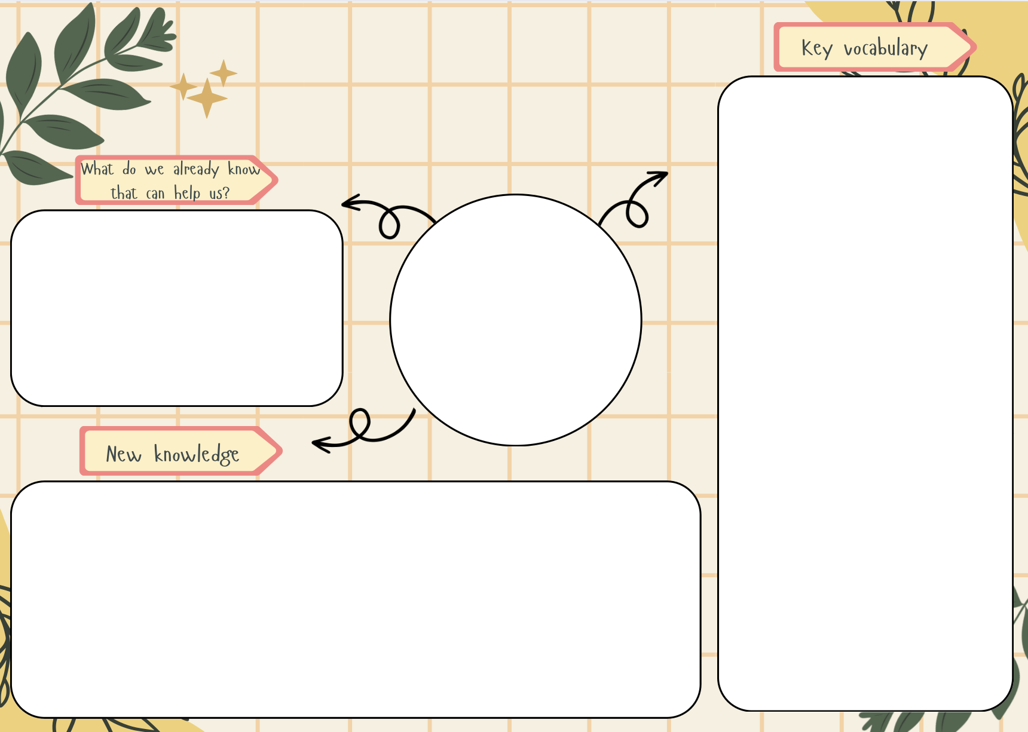
- We have already learnt about different types of nouns in Year 3.
- We have learnt how to identify ‘being’ verbs.
- We have learnt about regular and irregular action verbs.
- We have identified subjects.
- We have recognised co-ordinating conjunctions.
- To identify common nouns, proper nouns, collective nouns, partitive nouns and abstract nouns
- To identify being verbs and the ‘to have’ verb
- To identify regular and irregular action verbs and verb phrases
- To identify phrasal verbs
- To identify subjects
- To be able to punctuate single-clause sentences
- To be able to punctuate single-clause sentences
- To identify co-ordinating conjunctions
- To identify compound subjects and dummy subjects
- To identify gerunds
- To punctuate the single-clause and multi-clause sentences that make up a paragraph
- Common and proper nouns
- Collective and partitive nouns
- Abstract nouns
- Subject and verb
- Sentence
- Clause
- Co-ordinating conjunction
- Regular and irregular verbs
- Verb phrases
- Pronoun
- Capital letters and full stops
- Paragraph
- Compound and dummy subjects
- Gerunds
PVPG
English

