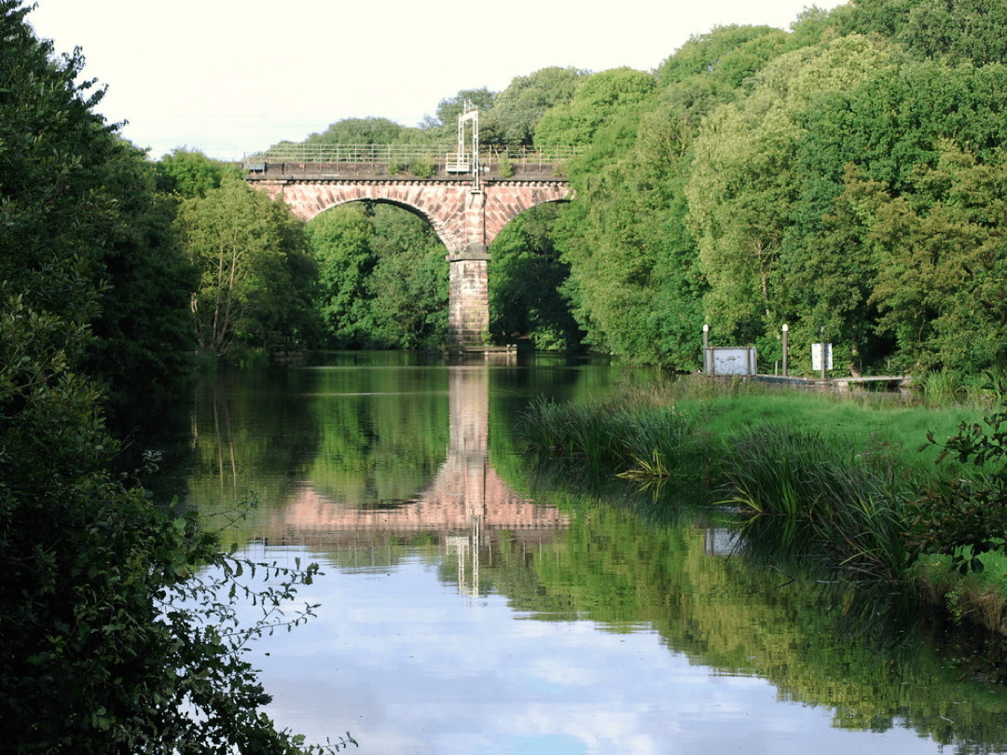

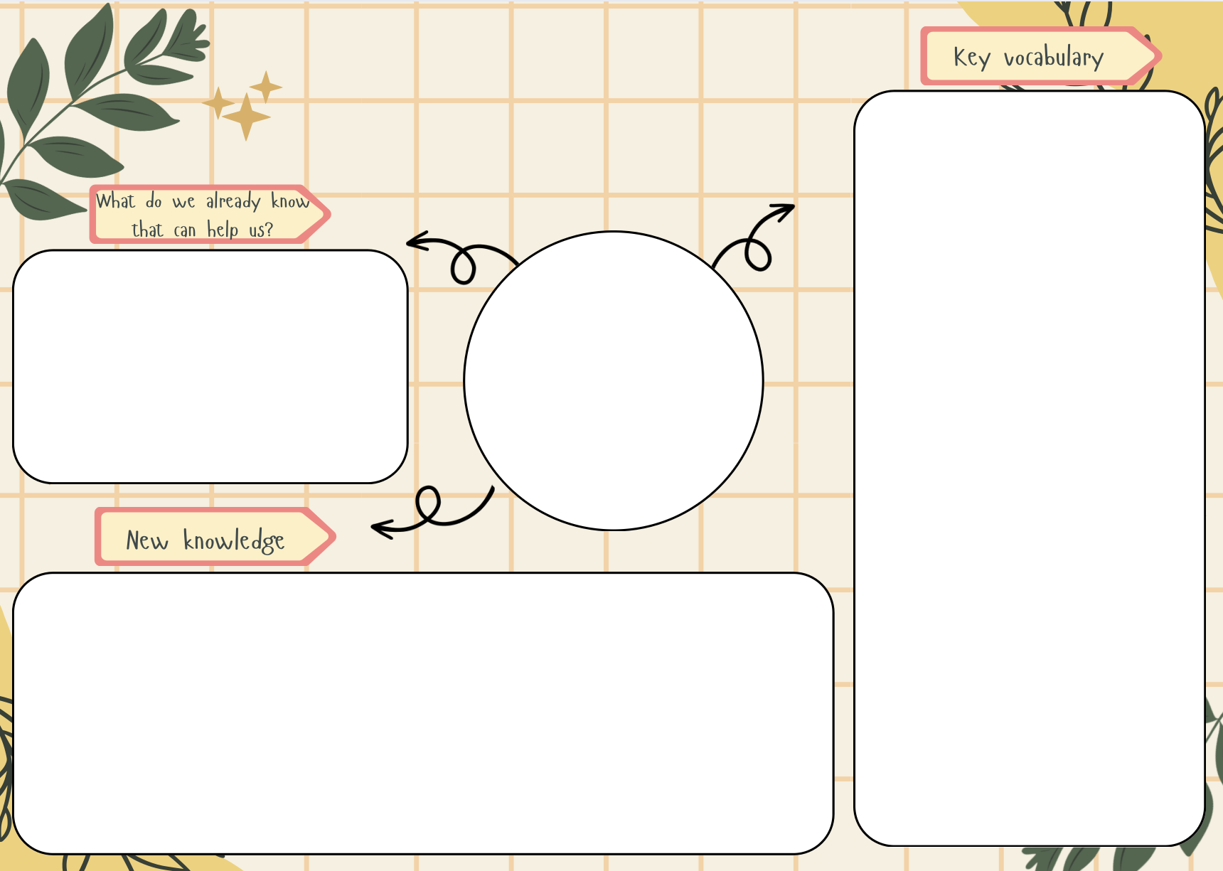
Conservation - protecting and looking after the natural world

Delta - a landform that forms at the mouth of a river, where the river flows into the sea

Ecosystem - the term used to describe how a community of living things interact with each other and their environment

Erosion - the process where the river's current wears away and transports material from its bed and banks

Estuary - occurs when a river slows and widens to flow into the sea – saltwater mixes with freshwater

Floodplain - flat land near a river

Meander - a bend in a river

Mouth - the place where a river meets the sea

Pollution - when harmful substances make the environment dirty or unsafe

Source - the beginning of a river that is likely to flood

Tributary - a stream or river that flows into a larger river or lake

Water cycle - the process by which the world’s water moves between lakes, rivers, the atmosphere, oceans and land
- A river is a moving body of water that drains the land. It flows from its source on high ground, across land, and then into another body of water. This could be a lake, the sea, an ocean or even another river. A river flows along a channel with banks on both sides and a bed at the bottom.
- Rivers can be divided into three stages:
Upper Course –The start of the river, usually in hills or mountains, where the water is fast and the river cuts into the land.
Middle Course – The middle part of the river, where it flows more gently, the valley widens, and the river starts to meander.
Lower Course – The end of the river, where it moves slowly, the valley is wide and flat, and the river may form a delta before reaching the sea or a lake.
- Rain falls and flows into rivers. Rivers carry water to the sea. Water evaporates back into clouds. Rivers are part of the cycle that keeps water moving.
- People use rivers for drinking water, farming, transport and energy (hydropower).
- We can protect our rivers by always putting rubbish in the bin, using less plastic, recycling, not pouring chemicals down the drain and joining/starting a river clean-up.

- Water comes from rivers, lakes, and the sea.
- Rivers flow downhill from higher places (like hills or mountains) to lower places (like lakes or the sea).
- Rain contributes to rivers and streams.
- Rivers provide water for people, animals, and plants. They can be used for transportation, farming, and recreation.
- Rivers can sometimes flood, affecting nearby land.
- Water moves from clouds → rain → rivers → sea → evaporation → clouds.
Rivers
Geography

