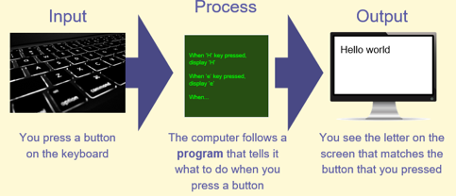

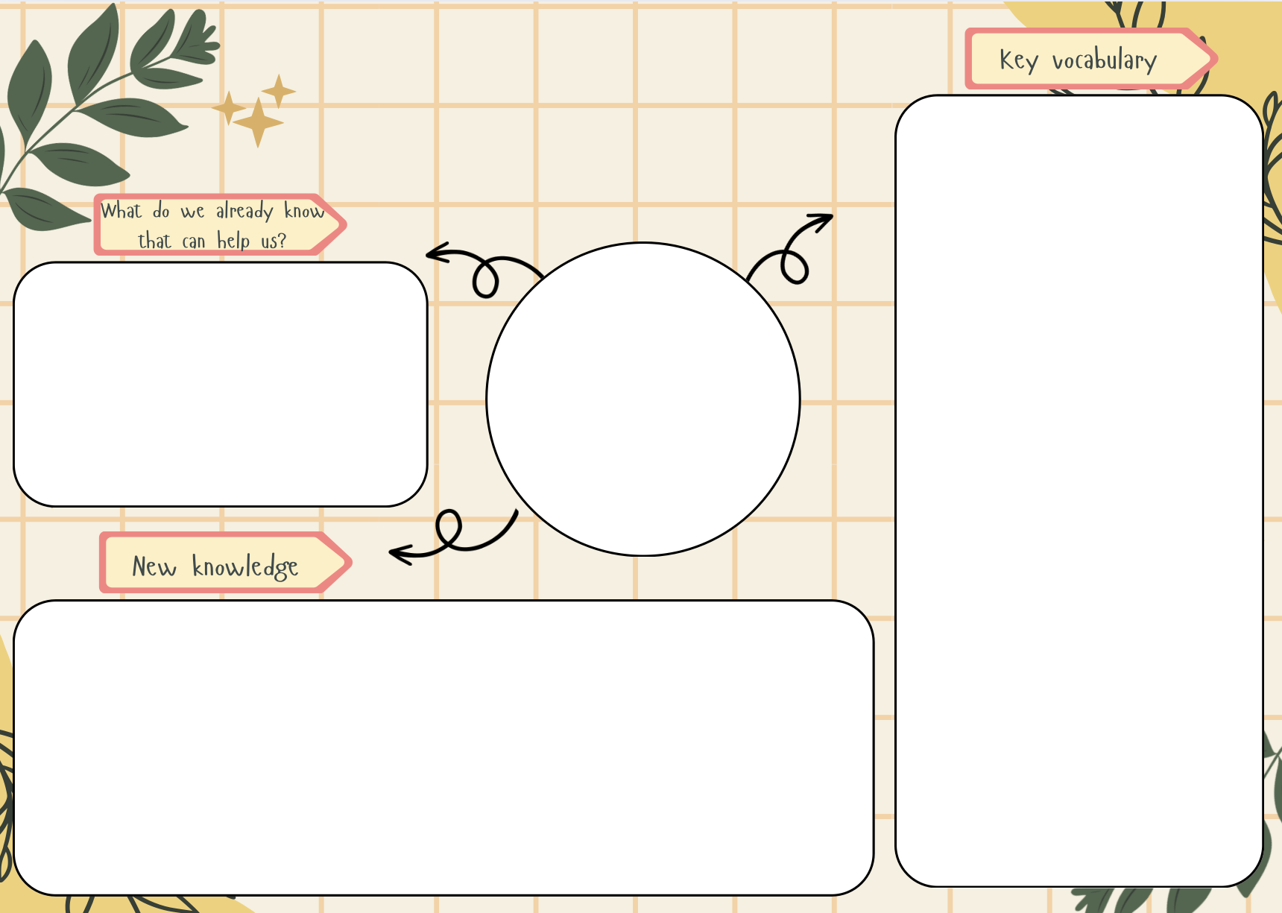
Digital device, input, output, process, network, network components, server, wireless access point, network switch, connections and router

Know how a digital device works.
Know what parts make up a digital device.
Know how a digital device helps us.
Know how we are connected.
Know how computers are connected.
Know what our school network looks like.

In KS1, pupils developed an understanding of technology and information technology (IT) and how this can benefit the, in their everyday lives. Now pupils will develop their understanding of digital devices, with an initial focus on inputs, processes, and outputs and discover the benefits of connecting devices in a network.

Information technology around us
Computing

