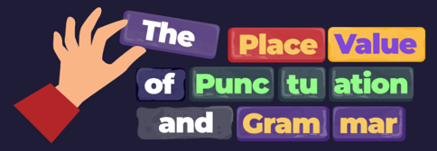
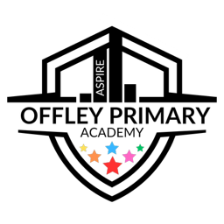
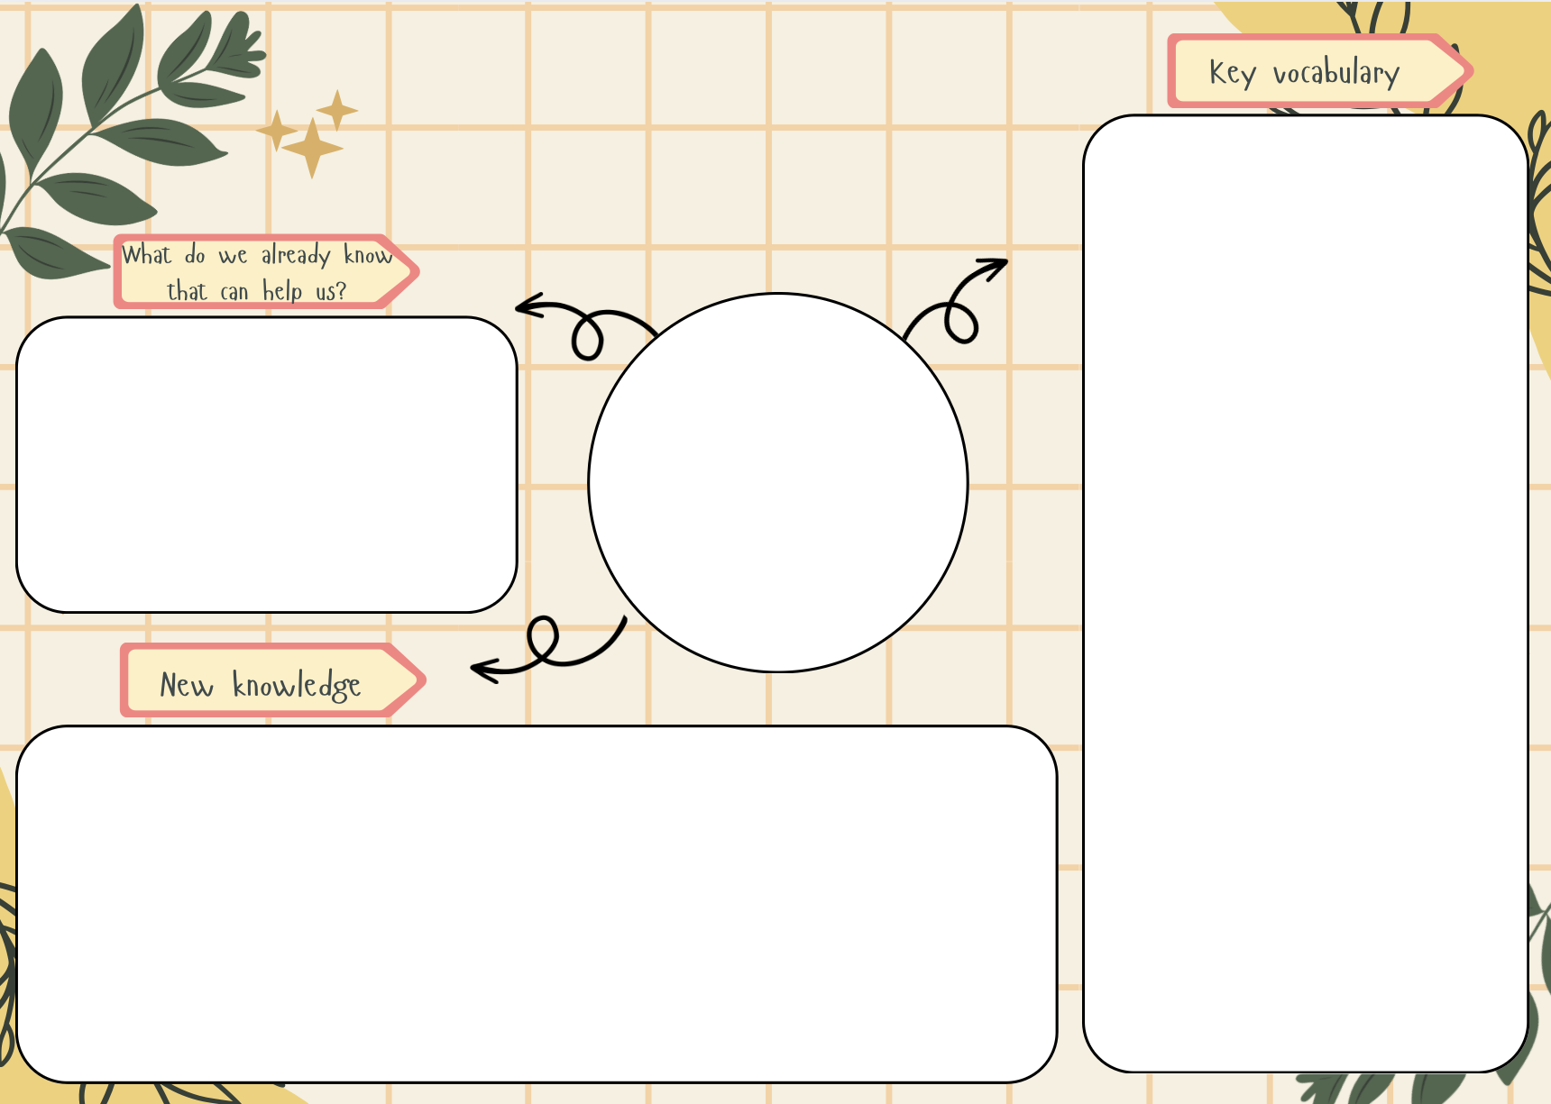
- Common and proper nouns
- Collective and partitive nouns
- Subject and verb
- Sentence
- Clause
- Conjunction
- Regular and irregular verbs
- Verb phrases
- Modal verb
- Pronoun
- Capital letters and full stops
- Paragraph
- To understand common and proper nouns
- To under collective/partitive nouns
- To recognise ‘being’ verbs
- To recognise and apply the verb ‘to have’
- To recognise regular action verbs
- To recognise irregular action verbs
- To define verb phrases.
- To recognise and define a subject.
- To recognise and define a single clause sentence.
- To recognise and define co-ordinating conjunctions.
- To define a compound subject.
- We have already learnt about common and proper nouns in Y2.
- We have learnt how to identify ‘being’ verbs in Y2.
- We have learnt about regular and irregular action verbs in Y2.
PVPG
English

