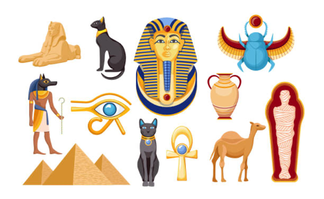

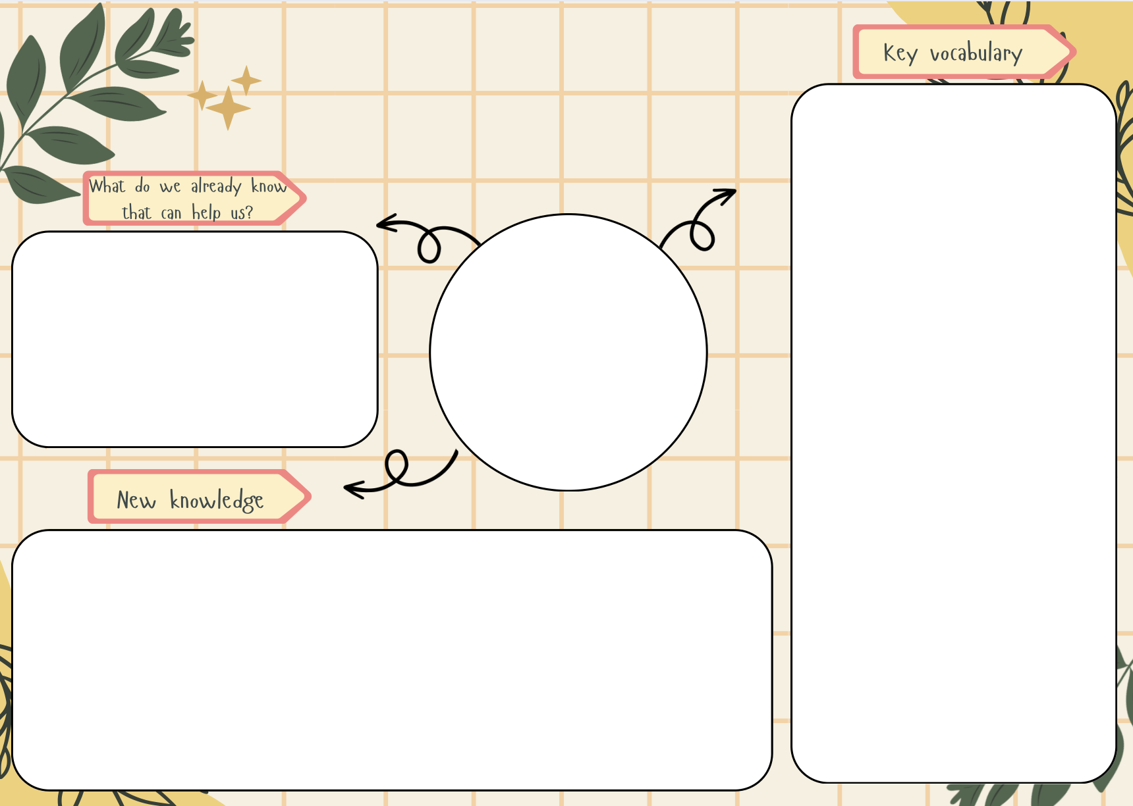
ancient - a long time ago
civilisation - a human society with its own organisation and culture
artefacts - an ornament or tool that is made by a human and is historically or culturally interesting
chronology - a series of past events and the time/order in which they happened
god/goddess - a spirit who is worshipped
AD - ano domini: used to show that a year is after the year in which Jesus Christ is thought to have been born
BC - before christ: used to show that a year is before the year in which Jesus Christ is thought to have been born
century - a period of 100 years
Pharaoh - a ruler/ supreme leader of Ancient Egypt and also the religious leader
floodplains - an area of low-lying land next to a river
polytheistic - the worship of multiple Gods/Goddesses
mummification - the process of embalming and preserving a body after death
canopic jar - a covered urn used in ancient Egyptian burials
The Ancient Egyptian empire began in 3150BC and lasted for over 3000 years. It occurred at the same time as the Stone Age, Bronze Age and Iron Age in the UK.
The Egyptian empire was located in North Eastern Africa and was ruled over by a supreme leader called a Pharaoh, who was also their religious leader. The ancient Egyptians were polytheistic, meaning they believed in more than one God/Goddess.
The ancient Egyptians built pyramids as tombs for their Pharaohs, along with mummifying their dead to preserve them for the afterlife.
Tutankhamun was a Pharaoh of historical significance because his tomb was discovered by British archaeologist Harold Carter in 1922, shedding light on the burial process as the only royal burial remaining in tact in modern times.
- The Egyptians were al civilisation of historical importance because they built the pyramids which still remain today.
- The ancient Egyptians preceded the Romans.
Ancient Egyptians
History

