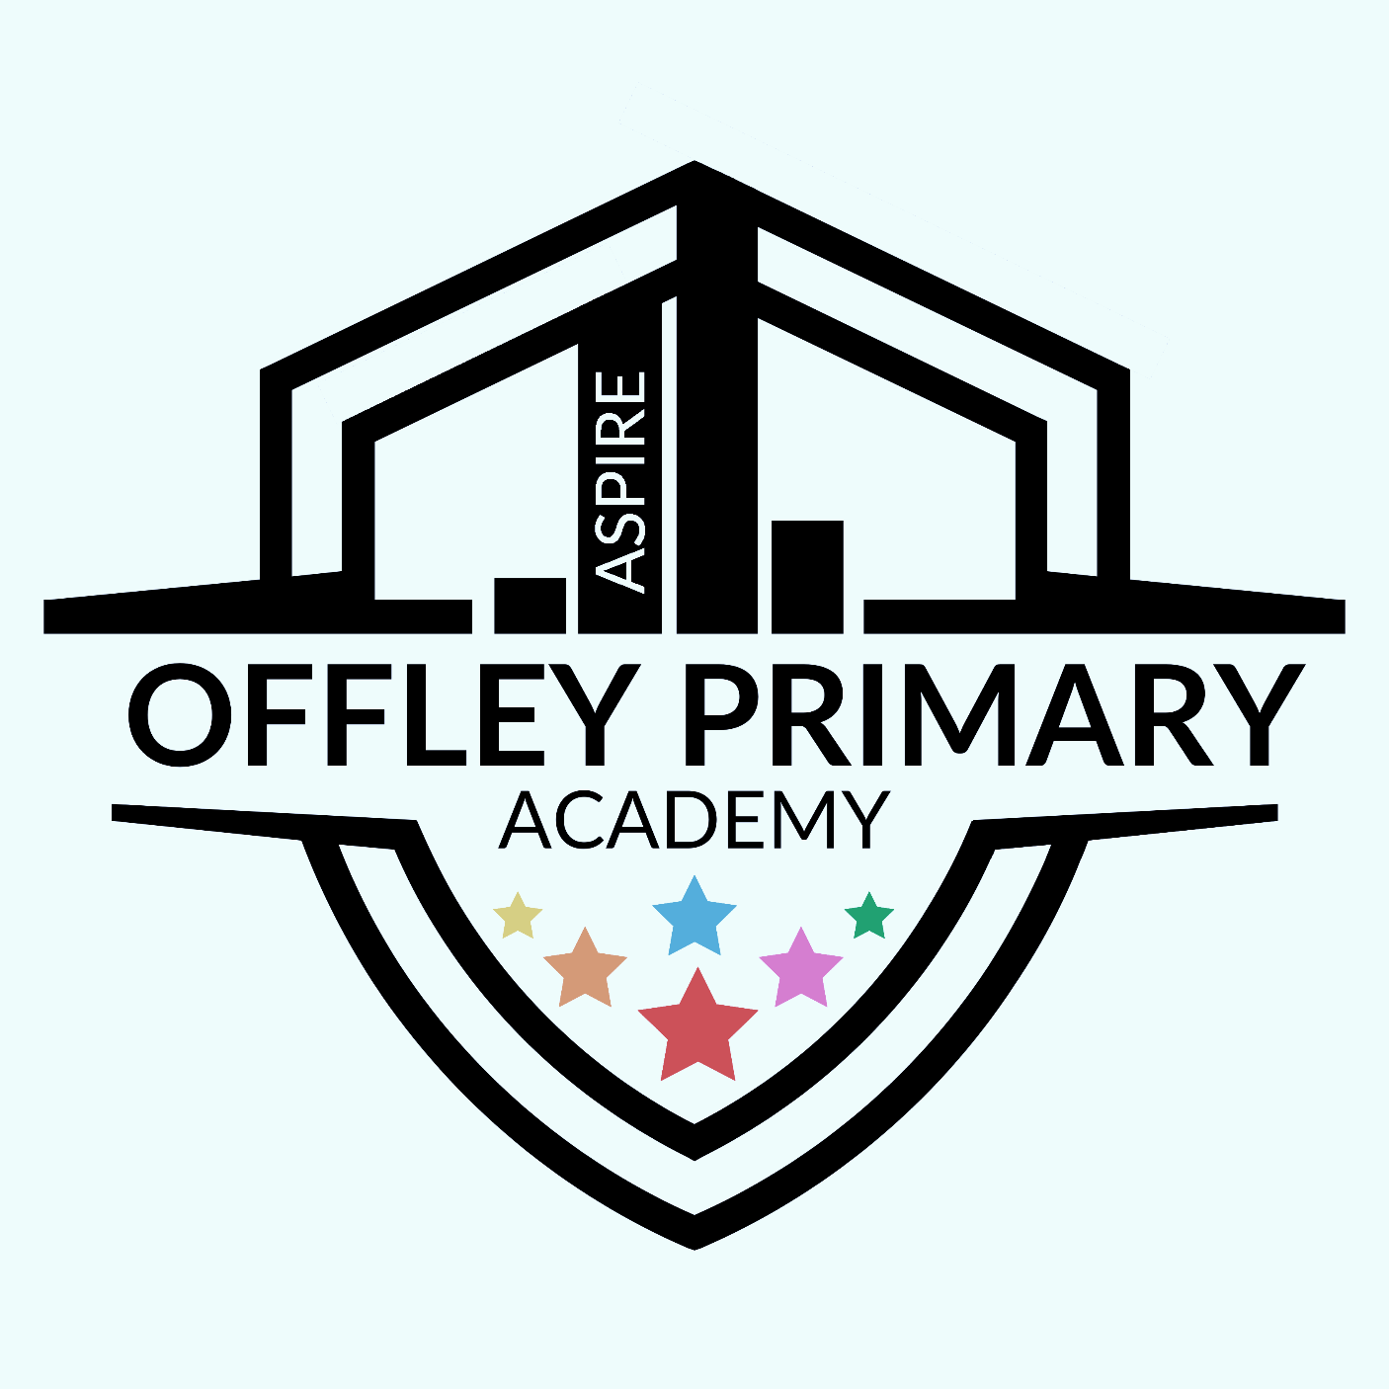

What do we already know?
We:
- Can sing a range of new songs
- Can move in time to the music
- Perform and improvise with songs with the glockenspiel as an accompaniment
Key Knowledge/Skills:
- I can communicate to others my thoughts and feelings about the music that I listen to.
- Listen with attention to detail and recall sounds with increasing aural memory.
- I can sing songs in unison and in multiple parts with increasing confidence.
- Listen with attention to detail and recall sounds with increasing aural memory.
- I can use a tuned instrument to play and perform in solo or ensemble contexts with confidence.
- Use and understand staff and other musical notations.
- Play and perform in solo and ensemble contexts, using their voices and playing musical instruments with increasing accuracy, fluency, control and expression.
- To play the right notes with secure rhythms.
- When improvising, I can follow a steady beat, keeping in time with the pulse of the music.
- To become more skilled in improvising, perhaps trying
- more notes and rhythms.
- I can use additional notes and rhythms to show progression.
and perform complex rhythmic patterns, including triplets as a call and response exercise, both aurally and visually. formal, written notation which includes semibreves, triplets and dotted crotchets, recognising their position on a stave.

Key Vocabulary:
- Listening
- Finding and keeping a steady beat
- Copy back Improvisation
- Singing Playing instruments
- Reading notation
- Pulse/beat
- Rhythm
- Pitch /Tempo/timbre/texture /Dynamics/structure/melody/harmony
Recommended Wider listening/singing
Lively by Quinn Mason
His Eye Is On The Sparrow by Civilla D. Martin and Charles H. Gabriel


Melody and Harmony
Year group: 5
Term: Autumn 1

