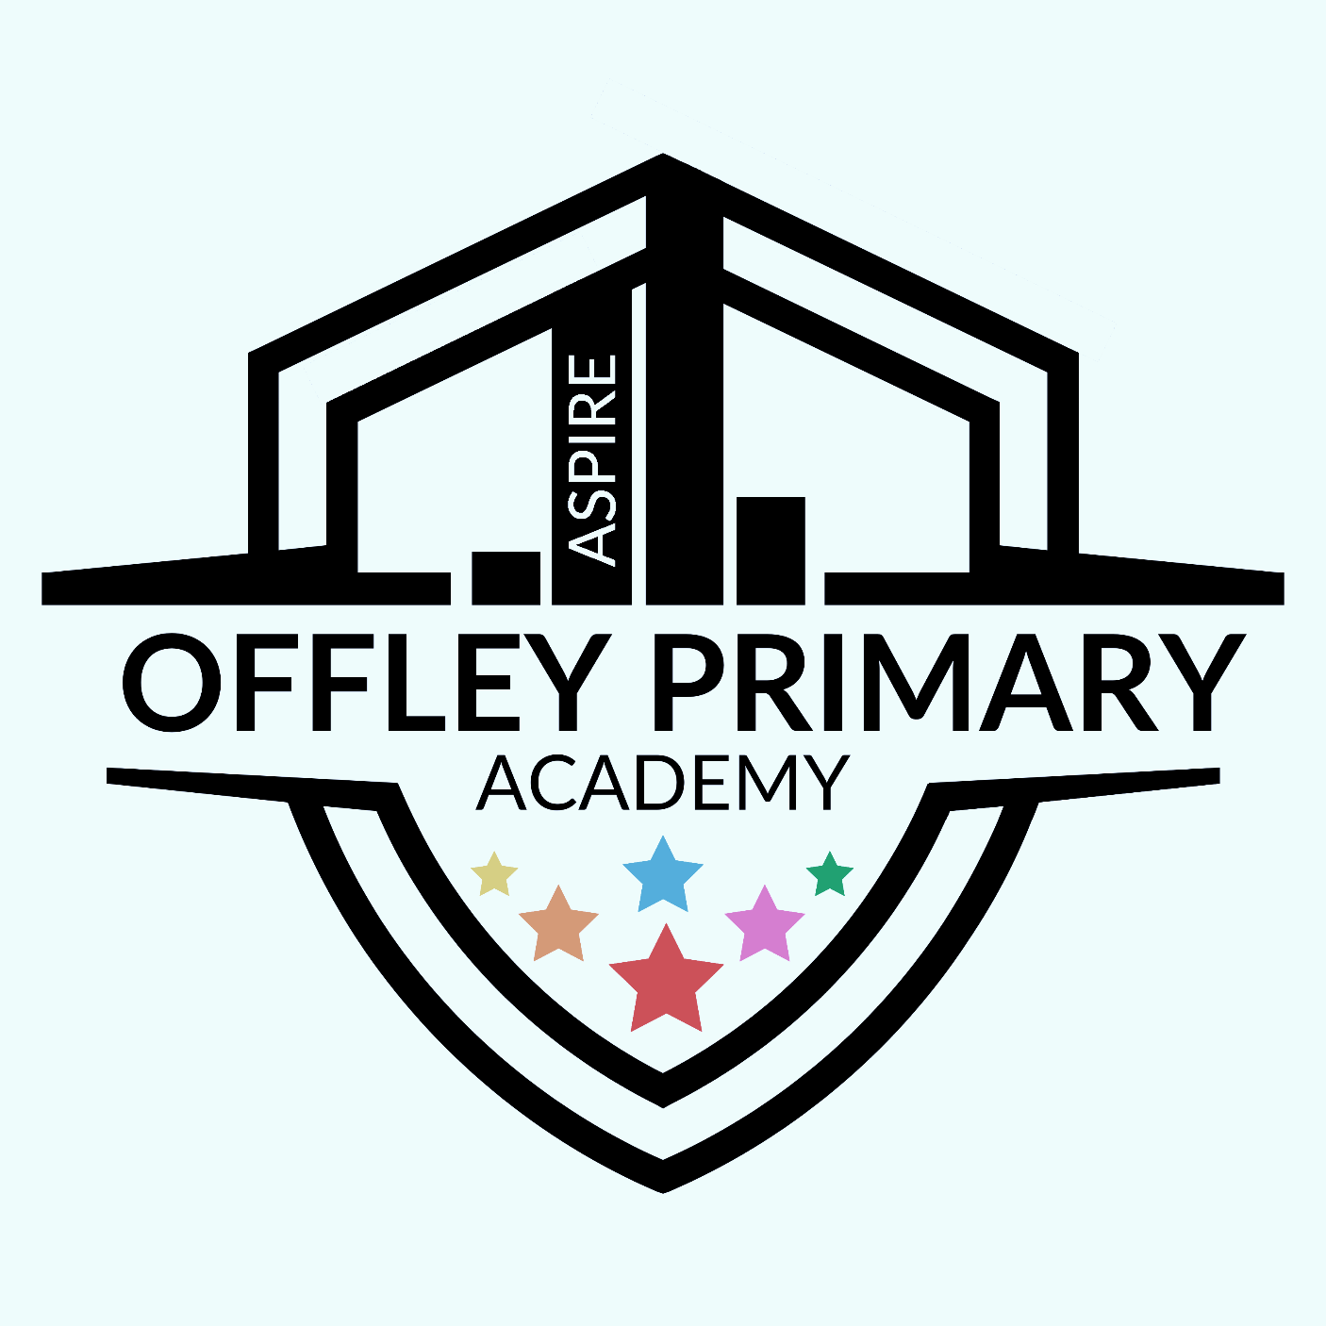
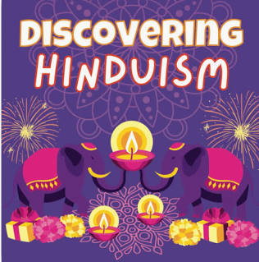
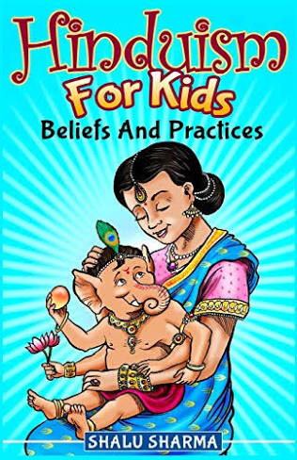
Key Vocabulary:
- Swastika – An ancient Hindu symbol of good luck and well-being.
- Rama – A Hindu god and hero of the story Ramayana. He shows courage, kindness, and doing what is right.
- Sita – Rama’s wife in the Ramayana. She is seen as a model of loyalty and devotion.
- Vishnu – One of the main Hindu gods, known as the preserver of the world. Hindus believe he has appeared on Earth in different forms (avatars), like Rama and Krishna.
- Brahman – The one eternal spirit or supreme power in Hinduism that everything comes from and is part of.
- Puja – A prayer ritual where Hindus show love and respect to a god, often with offerings like flowers, food, or incense.
- Diwali – The Hindu festival of lights, celebrating the victory of light over darkness and good over evil.
- Holi – The Hindu spring festival of colours, when people throw coloured powders and celebrate friendship and joy.
- Dharma – A Hindu idea about duty and living in the right way—being kind, fair, and responsible.

What do we already know?

As Hinduism has not previously been covered, all of the content in this unit will be new learning for the children.
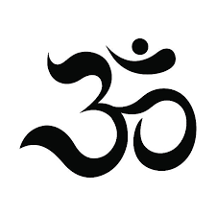

Year group: 5
Term: Autumn 1
Recommended Wider Reading:

Key Knowledge/Skills:

- Explain the key events in the Divali & Holi stories and how Hindus may celebrate.
- Make links with the behaviour of Rama & Sita in the Diwali story; aspects of how Hindus celebrate Diwali (e.g. cleaning out the house & the goodness of Rama & Sita) and the idea of overcoming evil in life today/temptation
- Talk about what influences behaviour for good and for evil today.
- Describe what some Hindus do to fulfil their duties.
- Identify various types of shrines that Hindus use in temple or at home and explain how artefacts are used in worship at home and in the temple eg bells, water, fruit, flowers, incense.
- Explain different ways Hindu might worship eg in the temple, at home.
- Explain the symbolism of items found on a Hindu shrine.
- Understand that Hindu worship is largely individual not communal.

