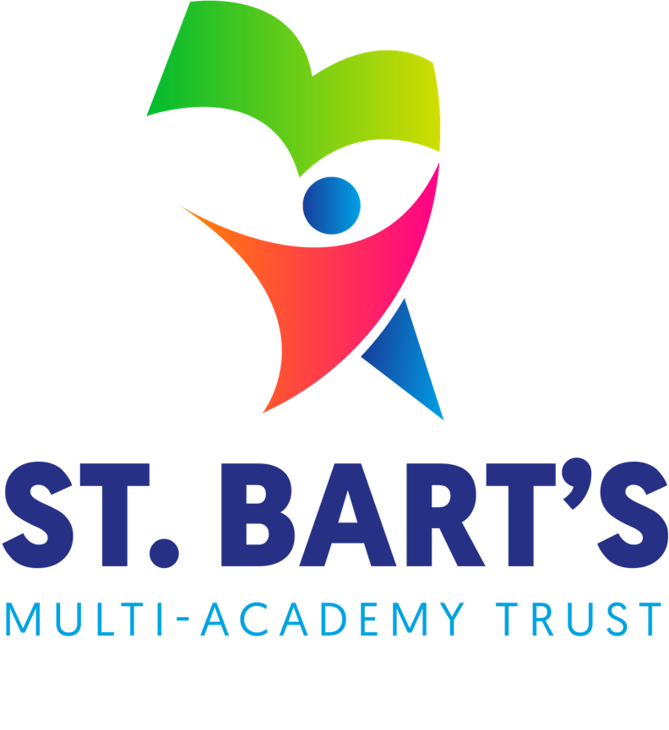

Accessibility
Plan

April 2025

St. Bart’s Multi-Academy Trust
Accessibility Plan
Produced Date: |  | April 2025
Approved by Trust Board: |  | 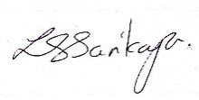 | Lisa Sarikaya  Chief Executive Officer
Review Date: |  | September 2026
Date | Section Amended |  |  | Signature
01/03/2023 | TSB Policy Adopted – v4 |  |  | S. Jones
06/02/2024 | Wording and content reviewed- no identified amendments. |  |  | Mrs S. Cope
10/04/2025 | Wording and content reviewed- no identified amendments. |  |  | Mrs L. Henshall

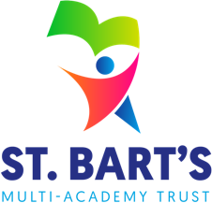

Contents

St. Bart’s Mission 4
St. Bart’s Vision and Values 4
St. Bart’s Sustainability 4
Accessibility Plan 5
Statement of intent 5
1. Accessibility Plan 6
2. Planning Duty 1: Curriculum 7
3. Planning Duty 2: Physical Environment 8
4. Planning Duty 3: Information 9

St. Bart’s Mission
Our mission is to ADVANCE EDUCATION and to provide the best curriculum in all our academies, enabling every child to realise their full potential.

St. Bart’s Vision and Values
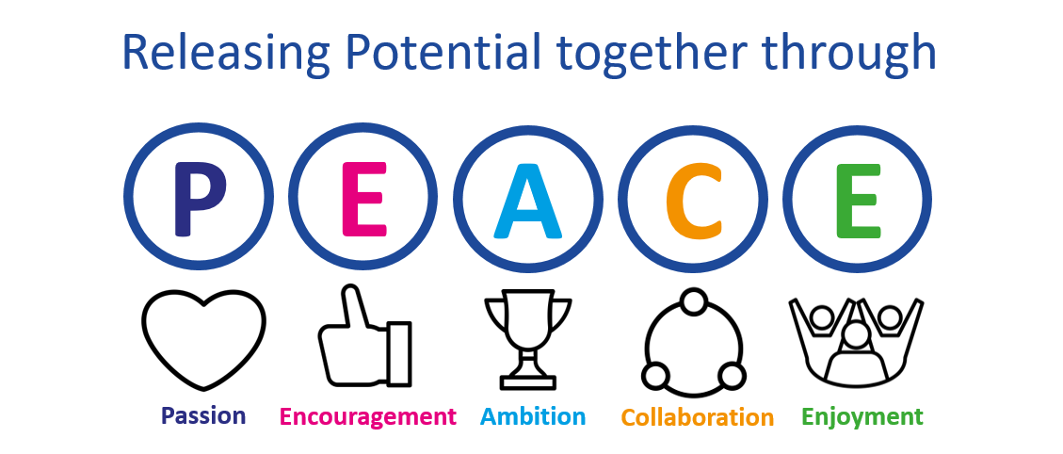
We have a Passion for releasing potential in all our children and staff through the Encouragement and development of Ambition, aspiration and excellence in all aspects of our work. Our commitment is to place children at the centre of everything we do. Working in Collaboration, we strive to provide the highest quality of educational experiences and outcomes for young people in an inclusive environment. Through the Enjoyment of learning, we live life together in all its fullness through PEACE.
We believe this vision empowers children with the skills to make a positive impact on the future of the communities they serve.
Our Trust Christian ethos is also captured by the PEACE values and all schools work in close partnership (whether C of E or community) to ensure that all children, adults and the communities they serve flourish just as Jesus encouraged us to do in John 10:10 –
“I have come that they may have life, and have it to the full.”

St. Bart’s Sustainability
We are committed to educating our pupils about environmental concerns and the importance of living sustainably. We recognise our responsibility to ensure that pupils are prepared for a world impacted by climate change through learning and practical experience.
We encourage both pupils and staff to think about the environment and how their actions will impact upon their local surroundings, as well as the global environment.
We will ensure pupils are taught about environmental sustainability, promote an eco-friendly attitude, and ensure that the Trust itself is as sustainable as it can be.

Accessibility Plan

Statement of intent
This plan outlines how the academy aims to increase access to education for pupils with disabilities in the three areas required by the planning duties in the Equality Act 2010 (i.e. the curriculum, physical environment and information).
A person is regarded as having a disability under the Equality Act where they have a physical or mental impairment that has a substantial and long-term adverse effect on their ability to carry out normal day-to-day activities.
This plan aims to:
- Increase the extent to which pupils with disabilities can participate in the curriculum.
- Improve the physical environment of the Academy to enable pupils with disabilities to take better advantage of education, benefits, facilities and services provided.
- Improve the availability of accessible information to pupils with disabilities.

The above aims will be delivered within a reasonable timeframe, and in ways which are determined after taking into account pupils’ disabilities and the views of parents and pupils.
The Trust and its Academies also recognises its responsibilities towards employees with disabilities and will:
- Monitor recruitment procedures to ensure that individuals with disabilities are provided with equal opportunities.
- Provide appropriate support and provision for employees with disabilities to ensure that they can carry out their work effectively without barriers.
- Undertake reasonable adjustments to enable staff to access the workplace.

The plan will be resourced, implemented, reviewed and revised in consultation with:
- Pupils’ parents.
- The Principal and other relevant members of staff.
- Governors.
- External partners.

- Accessibility Plan – 2025-2028
Our Accessibility Plan sets out how this Academy will improve equality of opportunity for disabled people. This plan sets out the establishment’s proposals to increase access to education for disabled pupils in the following three areas:
- Increasing the extent to which disabled pupils can participate in the curriculum on an equal basis with their peers;
- Improving the physical environment of the establishment to enable disabled pupils to take better advantage of education and associated facilities and services; and
- Improving the availability of accessible information to disabled pupils.
The preparation of the Accessibility Plan has been informed by audits and analyses of data within the Academy and its premises. It is a requirement that the Accessibility Plan is resourced, implemented and reviewed as necessary and at least annually. A copy of this Plan together with the SBMAT Accessibility Policy will be placed upon our website.
This plan will be reviewed on an annual basis by the Local Governing Committee and Principal. Any changes to this plan will be communicated to all staff members and relevant stakeholders.
[Please note that the actions in the tables below are examples only. You must amend the content of the tables to reflect your Academy’s actions.

- Planning Duty 1: Curriculum
Issue / Action | Lead Responsible | Identified Budget  and any other resources | Target Date | Success Criteria
Monitor curriculum to ensure resources are chosen to celebrate cultural diversity. | Curriculum Lead | Release time | Summer 2026 | All subjects have intercultural elements  Books in the school library
All pupils being challenged to meet their full potential | All staff | Release time | Autumn 2025 | More pupils are identified as greater depth in their learning and pupils are making accelerated progress
To improve the emotional health and well-being of all pupils | Mental Health lead | Release time for monitoring | Summer 2026 | Pupils have the opportunity to see the school counsellor or play therapist to support.  Pupils talk openly about supporting their mental health with school staff  Pupils access the internal SEN room when needed.
To ensure that all pupils have the opportunity to be involved in extra-curricular activities | All staff | Staff time | Autumn 2026 | Greater number of pupils attending the clubs  A wider range of clubs on offer for the children to enjoy.  More pupils are representing the school in sporting and non -sporting competitions and festivals.
To include to develop the use of iPad technology to ensure the accessibility tools are fully utilised for all pupils. | Digital Lead/All Staff | Staff meeting time - CPD | On-going | Staff training has been delivered to all staff and the iPads enhance the curriculum and pupils are accessing these accessibility tools independently regardless of ability, disability or need.

- Planning Duty 2: Physical Environment
Issue / Action | Lead Responsible | Identified Budget  and any other resources | Target Date | Success Criteria
Liaison with Inclusion Service (Occupational Therapy, Physiotherapist, SALT, Dyslexia Training, School counsellor and School Nurse) to ensure children have equipment, aids and any skills/tools they can use specific to their needs. | SENCO | £1000 | On going | To provide appropriate and effective resources and equipment to enable all pupils to have access to an education.
To improve the physical environment of the school to enable all children, families and wider community to access the school and its facilities. | SLT | £1000 | Summer 20026 | School is viewed as a welcome, encouraging establishment where we offer support and promote multi-agency working.
To give consideration to the physical environment in any school development plans – including installation of visual aids, equipment | SLT | £500 | On-going – annually | Regular SLT meetings discuss the accessibility of the physical environment and when planning environmental developments.
To provide an area of school that pupils can utilise when they are struggling to regulate their emotions/dysregulated. | SENCO/SLT | £10000 | September 2025 | Pupils will be able to freely access the internal provision to meet their needs.  Pupils’ needs will be met by them accessing the internal provision for activities e.g. sensory circuits.

- Planning Duty 3: Information
Issue / Action | Lead Responsible | Identified Budget  and any other resources | Target Date | Success Criteria
To ensure that all parents / guardians are able to access all communication between home and school. | SLT/Office Staff | None | September 20 | Parents will have multiple options to access communication from school – website, email, Facebook and paper copy, if required.
The school website to be easily accessible for all information to support all parents. | SLT | Time | Spring 2026 | Parents will be able to use the Academy website with ease to access communication and information to support their child in school.
Parents to be able to use the accessibility tools on their home devices to full access communication | SLT | Time | Summer 2026 | Parents will have attended workshops to showcase the school’s inclusion work using the iPads.  The accessibility tools, shared with the parents through the workshops, will be used by parents to access information sent from school e.g. text to speak.

St. Bart’s Multi-Academy Trust
c/o Belgrave St. Bartholomew’s Academy,
Sussex Place, Longton, Stoke-on-Trent, Staffordshire, ST3 4TP
www.sbmat.org T: 01782 486350

