
What do we already know?
• The Earth is a planet and the Sun is a star.
• Some objects in space, such as the Moon, can be seen from Earth.
• Day and night are linked to the position of the Earth and Sun.
• Planets are part of our Solar System.

Recommended Wider Reading:

- DK Eyewitness: Space
• Professor Astro Cat’s Frontiers of Space by Dr Dominic Walliman
• George’s Secret Key to the Universe by Lucy and Stephen Hawking
• Look for child-friendly NASA or UK Space Agency articles and videos.

Key Vocabulary:
• axis – an imaginary line through the Earth from the North Pole to the South Pole.
• orbit – the curved path an object follows as it travels around another object.
• rotation – when an object spins around its axis.
• planet – a large, nearly spherical body that orbits a star.
• solar system – the Sun and all the objects that orbit it.
• celestial body – a natural object in space, such as a planet, moon or star.
• daylight – the part of Earth facing the Sun.
• night-time – the part of Earth facing away from the Sun.

Key Knowledge/Skills:

• The Sun, Earth and Moon are approximately spherical bodies.

• The Earth orbits the Sun and takes approximately 365¼ days to complete one orbit.

• The Earth rotates on its axis once every 24 hours.

• The Earth's rotation causes day and night.

• The Moon orbits the Earth.

• The apparent movement of the Sun across the sky is caused by the Earth's rotation.

• Different planets have different sizes, distances from the Sun and lengths of day and year.

• Use models, diagrams and evidence to explain how movement in space causes observable patterns.

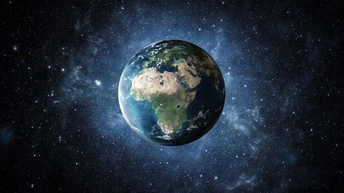
Year group: 5
Term: Autumn 1

