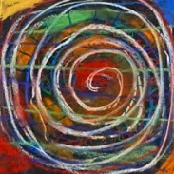
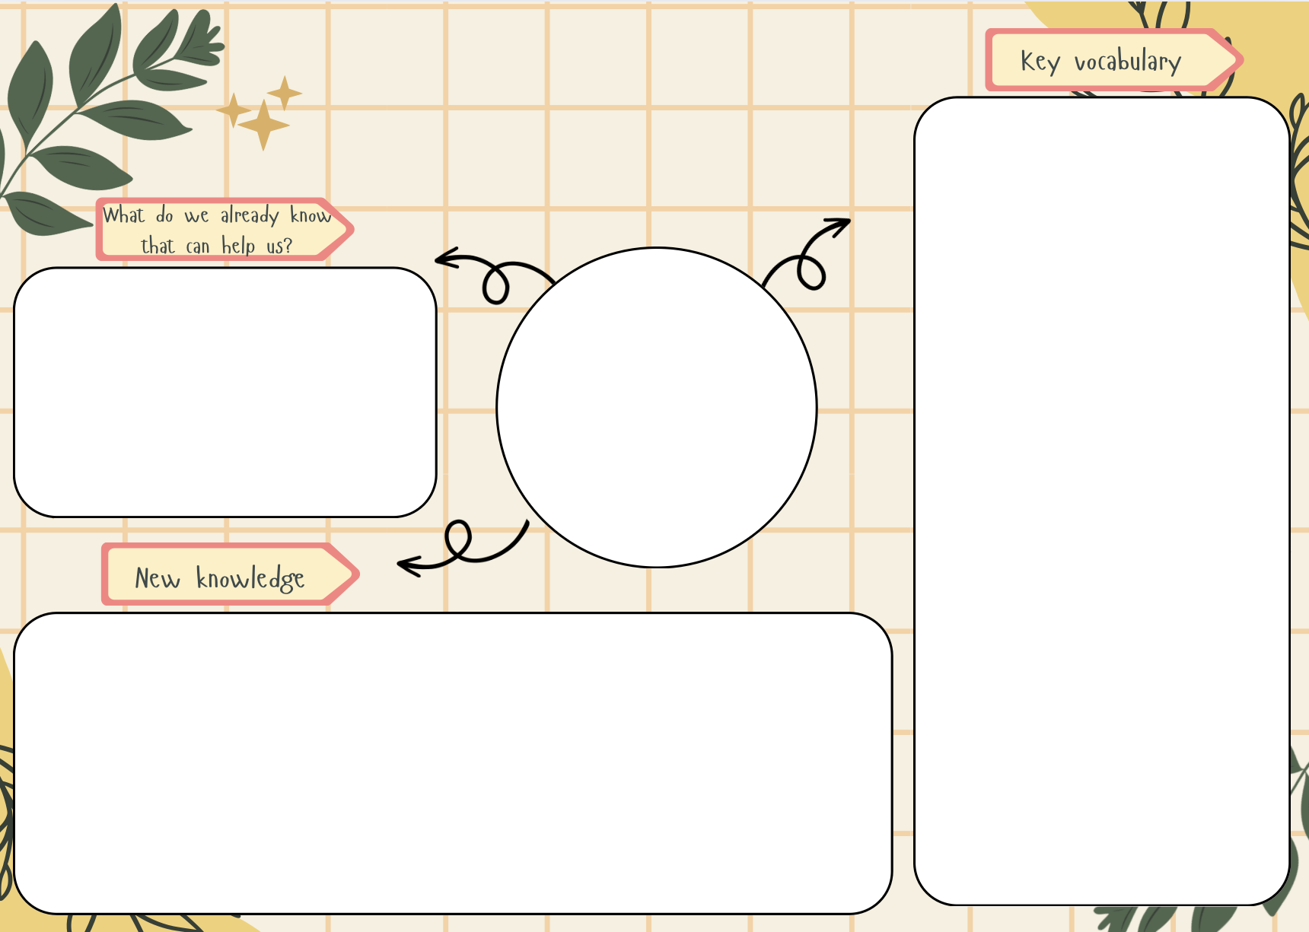
- I can draw from my finger tips, my wrist, my elbow, my shoulder, my body.
- I can make different marks with different drawing tools.
- I have seen the work of an artist and listened to how the artist made the work.
- I can share how I feel about the work.
- I can make choices about which colours I’d like to use in my drawings.
- I can make different marks with different drawing tools.
- I can draw from observation for a few minutes at a time.
- I can make a drawing using continuous line for a minute or two.
- I can make different marks with different materials.
- I can talk about what I like in my drawings, and what I’d like to try again.
- I can listen to other pupils discussing their work.

I can already safely use and explore a variety of materials, tools and techniques, experimenting with colour, design and texture.

Spirals
Art

Spiral
Movement
Pressure
Motion
Line
Continuous Line
Small
Slow
Larger
Faster
Careful
Oil Pastel
Dark
Light
Blending
Mark Making

