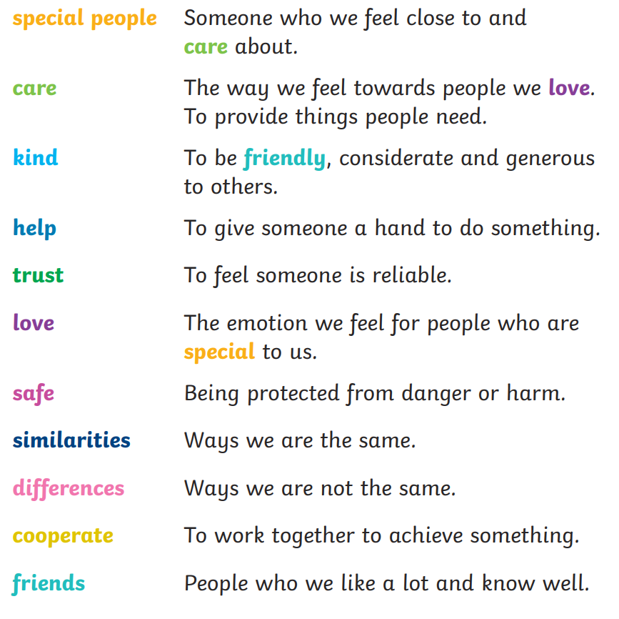
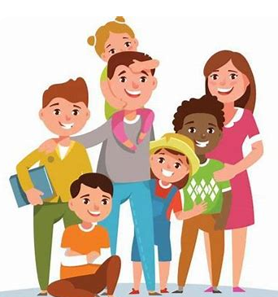
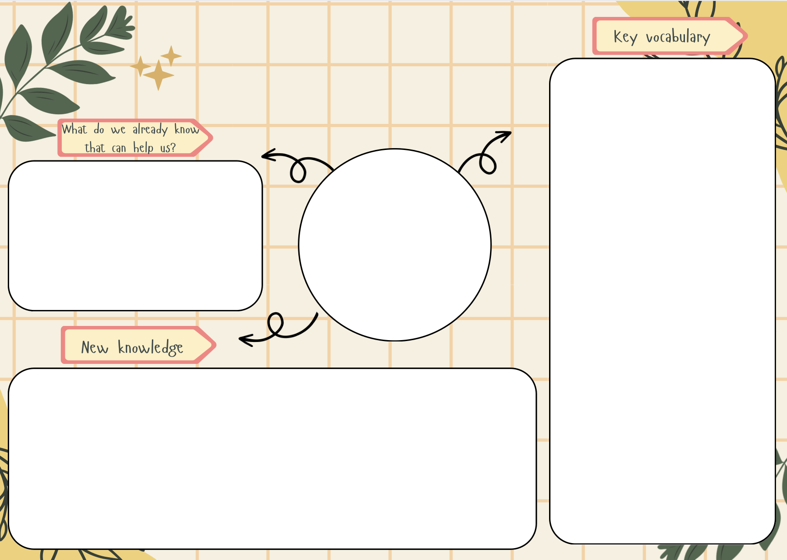

- Explore how families can be different
- Learn about the characteristics and impact of positive friendships
- Learn that issues can be overcome
- Understand that people show feelings differently and that stereotyping is unfair
We will do this by:
- Understanding who is special to us
- Showing we care about others
- Recognising other people’s emotions
- Working with others
- Understanding each other’s families and how they are all different
- Challenging gender stereotypes

Families & Relationships
- I am a valuable individual.
- I can build constructive and respectful relationships.
- I can express my feelings and consider the feelings of others.
- I show resilience and perseverance in the face of challenge.
- I can identify and moderate my own feelings socially and emotionally.

pshe

