
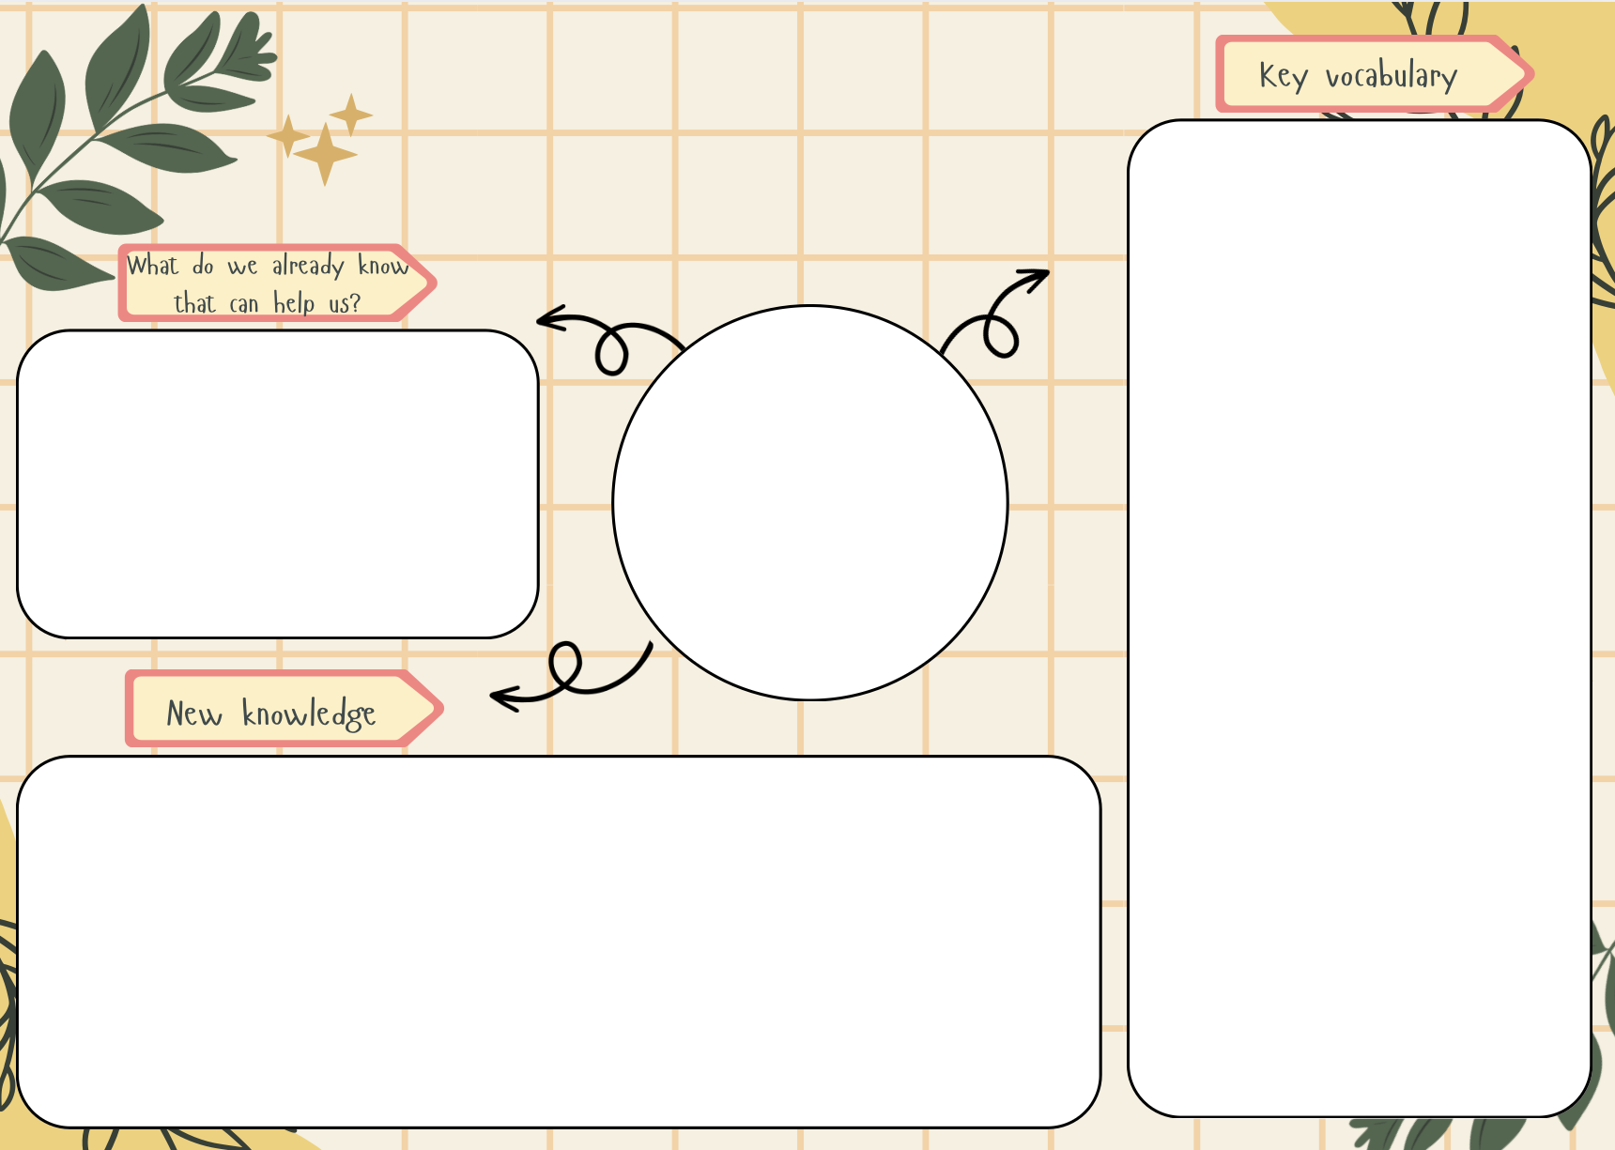
What is my school like?
map

aerial photograph

features

route

soil

vegetation

near

far

left

right

human features

buildings

playgrounds

field

physical features

wild area

Name, locate and identify features of our school grounds.

Label features on an aerial map of the school grounds.

Use locational language – near, far, left, right to identify where things are.

Draw a route on a map of the school grounds.

Discuss what they like/dislike about the school grounds and suggest how they can be improved.

In Reception the pupils developed an awareness of their immediate environment in school. They explored the natural world around them and made observations. They also began to draw basic maps by showing roads and famous landmarks.

Geography

